# **Installation of Apache 2.4 and enabling Reverse Proxy over it**

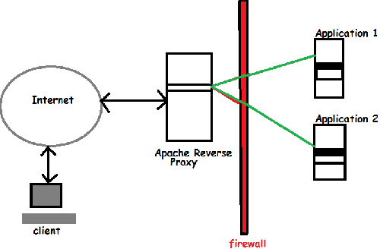

## Steps to be followed are:

1. Create an EC2 instance using RHEL 7.2
2. Configure the security groups, keeping HTTP and HTTPS open for all(only testing purpose)
3. Connect to the instance(SSH to it)
4. Follow the apache installation process given below:
   1. yum install -y -q httpd24-httpd // for installation of version 2.4
   2. rpm -q httpd // for checking the version of Apache installed
5. Modules Required for Reverse Proxy to Work:
   1. mod_proxy.so
   2. mod_proxy_http.so

The module mod_proxydeals with proxying in apache and mod_proxy_http handles connections with both http and https. Both the modules must be enabled in the config file. (“httpd.conf” for RHEL)

1. Check the location of both the modules using the given commands:
   1. find / -name mod_proxy.so
   2. find / -name mod_proxy_http.so

// location will be “/usr/lib64/httpd/modules/mod_proxy.so”

1. Once we find that the modules are available we can start editing the config file of Apache to setup proxy.
2. Follow the given procedure to edit the config file:
   * 1. vi /etc/httpd/conf/httpd.conf
     2. Add the following lines of code in the config file:

LoadModule proxy_module modules/mod_proxy.so

LoadModule proxy_ftp_module modules/mod_proxy_ftp.so

LoadModule proxy_http_module modules/mod_proxy_http.so

LoadModule proxy_connect_module modules/mod_proxy_connect.so

LoadModule cache_module modules/mod_cache.so

// to load all the required modules

* + 1. Here given below is the remaining updates to be done in the httpd.conf file

<Proxy *>

Order deny, allow

Allow from all

</Proxy>

// the main argument that is required in the httpd.conf file to enable proxying

ProxyPass /app/ http://54.206.50.188:8080/ retry=0 timeout=5

// This directive asks the apache server to fetch data for /app from http://54.206.50.188:8080/

ProxyPassReverse /app/<http://54.206.50.188:8080/>

//This directive rewrites the original URL available to the Internet when the traffic is send back.

1. Start the Apache Web Server using:
   * 1. service httpd start
2. Check with the given URL on the browser, to check if the reverse proxying works.